

***Faculty management system***

**Team member:**

**Manar Hessin Mohammed.**

**Norhan Nageh Alabd.**

**Project Advisor:**

**Dr: Amani Ashraf.**

**________________________________________________________**

**Team member, skills and tasks of every member:**

|  |  |  |
| --- | --- | --- |
| Members Name | Skill Set | Tasks |
| **Manar Hessin Mohamed** | -Implementation of  Desktop project.  -Implementation of  Database.  -Documentation. | -Implement frontend of desktop application on visual.  -Implement backend of desktop application on visual.  _Implement database on sql server.  -Implement documentation. |
| **Norhan Nageh Alabd** | -Implementation of  Desktop project.  -Implementation of  Database.  -Documentation | -Implement frontend of desktop application on visual.  -Implement backend of desktop application on visual.  _Implement database on sql server.  -Implement documentation. |

***Our note: we do our tasks and our project together.***

**“The advantages of our team”**

**Our advantages are both of us:**

**1) We can work together.**

**2) We love teamwork, and there's no disagreement between us.**

**3)** **We both work together to understand everything we need, and no one presses the other, and we get together and understand everything.**

**The advantages of developer Manar:**

**1)** **Understanding and implementing what is required especially soft part.**

**2)** **Trying to implement the job with the full face( the injured).**

**The advantages of developer Norhan:**

**1)** **Trying to master the theoretical part and implement it and keep it up.**

**2)** **Trying to implement the job with the full face( the injured).**

**“The advantages of our project”**

**1)** **The development of the college and the establishment of its own system provide a lot of defects of the online dealing.**

**2)** **Knowledge of the defects of the offline and its development for the best.**

**3) Preparing the feasibility of the project:**

**\*\* Identifying the idea of project.**

**\*\*The initial feasibility study.**

**\*\* Quarterly feasibility study.**

**4)** **Agreement between the developers of the project.**

**5)** **Clear and proper planning.**

**6) Good communication between developers.**

**7)** **The labor market and technological life need a lot of advanced projects that are able to deal online.**

**__________________________________________________**

**“Questionnaire of project”**

**College management system**

**Analysist name: Manar Hessin, Norhan Nageh**

**The name of the master: …………**

**Any modification: …………………..**

**___________________________________________**

**You can share this questionnaire because it is about the system of the college:**

**1) How likely is it that you would recommend this faculty system?**

**2)** **Do you think the system will solve your problems?**

**Yes No Maybe**

**3) Do you need a lot of time to spend your needs?**

**Yes No**

**4)** **What's your biggest priority right now?**

**5) Have you dealt with System before?**

**Yes No**

**6)** **Are there any advantages in dealing offline?**

**Yes No Maybe**

**7) What are the dis advantages of offline?**

**8)** **Do you speak English well?**

**Yes No**

**9)** **What are your expectations for the system?**

**10) Do you have any other comments, questions?**

**“Interview before project”**

***To a student:***

**1) Can you share a little about yourself?**

**2 What problems do you want the system to solve?**

**3) Would you recommend anything to create a strong system?**

**4) What are the weaknesses of the program from your point of view?**

**5) What are the Manifestations of power of the program from your point of view?**

***To a professor:***

**1) Can you share a little about yourself?**

**2) Why are you interested in building this system?**

**3) Do you suggest certain colors when designing the system?**

***To faculty affairs:***

**1) Can you share a little about yourself?**

**2) What problems do you want the system to solve?**

**_______________________________________________**

**“The Description of our project”**

Our project is about an online college system that provides comfort for students and professors. Once the student registers his data, he can register his courses and see the assignments and exams that the professor downloads, and he can deal with them and solve them, student can assign courses by his GPA, he can check courses and choose suitable course. As for the professor, he can download assignments and exams on the system for student; faculty affairs can manage information of students and professors and check their data.

In our project we use c# and our project is desktop application, we use sql server for database.

_______________________________________________

“Use case”

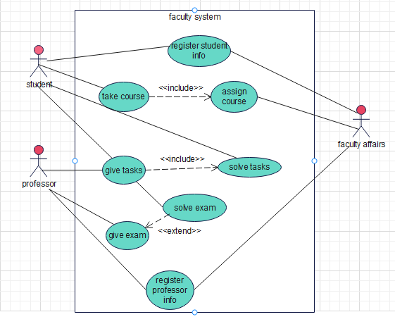

**_______________________________________**

**“Use case scenario”**

**Use case (1)**

**\*Use case: register student info**

**\* ID: mn1**

**\* Priority: High**

**\* Actors: student, faculty affairs**

**\* Type: External**

**\* Preconditions: -the student has a faculty account**

**\*post condition: the student shows his tasks, courses ,exams.**

**\* Main Scenario:**

**1. The student opens faculty’s website**

**2. The student clicks (log in). To be in system.**

**3. The student enters his private information.**

**4. The faculty affairs verify student’s information.**

**\* Extensions:**

**If the student enters incorrect information, The account creation will be cancelled.**

**Use case(2):**

**\* Use case: register professor info**

**\* ID: mn3**

**\* Priority: High**

**\* Actors: professor, faculty affairs**

**\* Type: External**

**\* Preconditions: -the professor has a faculty account**

**\*post condition: the professor add tasks , exams.**

**\* Main Scenario:**

**1. The professor opens faculty’s website**

**2. The professor clicks (log in). To be in system.**

**3. The professor enters his private information.**

**4. The faculty affairs verify professor’s information.**

**\* Extensions:**

**If the professor enters incorrect information, The account creation will be cancelled.**

**Use case ( 3)**

**\* Use case: give task**

**\* ID: mn4**

**\* Priority: low**

**\* Actors: student, professor**

**\* Type: External**

**\* Preconditions: -the student has a faculty account**

**\*post condition: the professor adds tasks and student solve tasks.**

**\* Main Scenario:**

**1. The student opens faculty’s website**

**2. The student clicks (log in). To be in system.**

**3. The student enters his private information.**

**4. The professor opens faculty’s website**

**5. The professor clicks (log in). To be in system.**

**6. The professor enters his private information.**

**7. The professor uploads tasks to the faculty's website**

**8. The student solves tasks on the faculty's website**

**\* Extensions:**

**If the professor and student enter incorrect information, the account creation will be cancelled.**

**Use case (4)**

**\* Use case: give exams**

**\* ID: mn4**

**\* Priority: low**

**\* Actors: student, professor**

**\* Type: External**

**\* Preconditions: -the student has a faculty account**

**\*post condition: the professor adds exams and student solve exams.**

**\* Main Scenario:**

**1. The student opens faculty’s website**

**2. The student clicks (log in). To be in system.**

**3. The student enters his private information.**

**4. The professor opens faculty’s website**

**5. The professor clicks (log in). To be in system.**

**6. The professor enters his private information.**

**7. The professor uploads exams to the faculty's website**

**8. The student solves exams on the faculty's website**

**\* Extensions:**

**If the professor and student enter incorrect information, the account creation will be cancelled.**

**Use case )5)**

**\* Use case: assign course**

**\* ID: mn4**

**\* Priority: low**

**\* Actors: student**

**\* Type: External**

**\* Preconditions: -the student has a faculty account**

**\*post condition: the student chose suitable course.**

**\* Main Scenario:**

**1. The student opens faculty’s website**

**2. The student clicks (log in). To be in system.**

**3. The student enters his private information.**

**4. The student chose suitable course.**

**5. The student assigns the course**

**\* Extensions:**

**If the professor and student enter incorrect information, the account creation will be cancelled.**

**_______________________________________________**

**“Feasibility study”**

**\* Technical Feasibility Includes:**

**▪ Familiarity with website: we should be aware of working process of the faculty system.**

**▪ Familiarity with Technology: Our actors should be excellent in desktop development**

**▪ Project Size: small project**

**▪ Compatibility: integrate the system with existing web browsers for computers**

***Technical Feasibility***

**\* Our project is coded in c#.**

**\* All the Codes can be easily implemented.**

**\* Database Connectivity is highly feasible and quickly operable.**

***Economic Feasibility***

**Our faculty system has the expected performance of the system when implemented under the physical and human equipment expected to be managed Our faculty system has the expected performance of the system when implemented under the physical and human equipment expected to be managed**

|  |  |  |  |  |  |  |
| --- | --- | --- | --- | --- | --- | --- |
|  | Year 0 | Year 1 | Year 2 | Year 3 | Year 4 | total |
| Total benefits |  |  | **$80.000** | **$130.000** | **$1200.00** | **$410.00** |
| Total costs | **$50.500** | **$50.500** | **$30.000** | **$35.400** | **$40.300** | **$406.7** |
| Net benefits | **$[250.500]** | **$[50.500]** | **$50.000** | **$94.6** | **$159.7** | **$3.3** |
| Cumulative Net Cash Flow | **$[250.500]** | **$[301]** | **$[251.00]** | **$[156.4]** | **$3.3** |  |

**Operational Feasibility:**

**Our project provides important information to the student and the university professor and gives him instructions to enter the software properly in addition to entering the private information correctly.**

**_______________________________________**

***“system request”***

**Project sponsor: it**

**Business Need:**

**1) Improve Access to information**

**2) Recording student data**

**3) Recording professors' data**

**4) Giving tasks through system**

**5) Giving exams to students through the system Business Requirements:**

**- Concept of Database**

**- Concept of Network**

**- Concept of desktop development c#.**

**Functionality:**

**- Provide certain searching and checking features students’ accounts.**

**- Provide very simple and modified features**

**- Provide certain searching and checking features professors’ accounts.**

**-Provide students with it and helps them take exams**

**-Provide students with it and helps them take tasks.**

**Intangible values: -**

**They can use it in emergency conditions like Corona because they don't go to college. -It extends communication between students and professors -save time and effort**

**Tangible values:**

**Saves money for the faculty safe by providing papers because they take exams online. - Print students' grades and certificates for distinguished students - facilitate the registration of student data and professor data.**

**____________________________________**

**“Context diagram”**

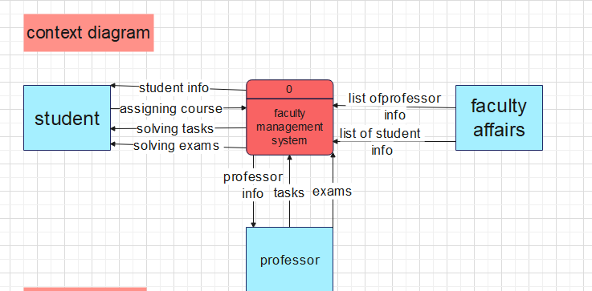

**________________________________________________**

**“Level 1 data flow”**

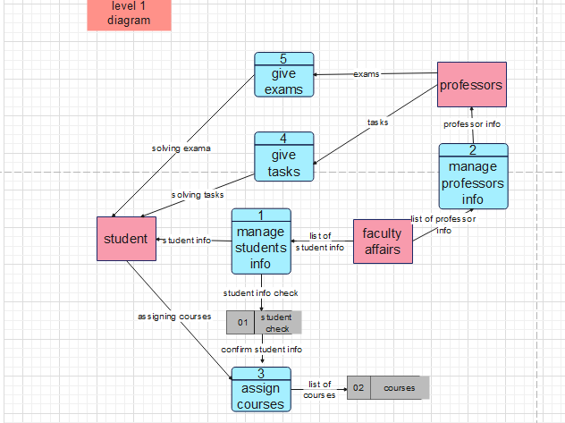

**________________________________________________**

**“Level 2 && logical diagram”**

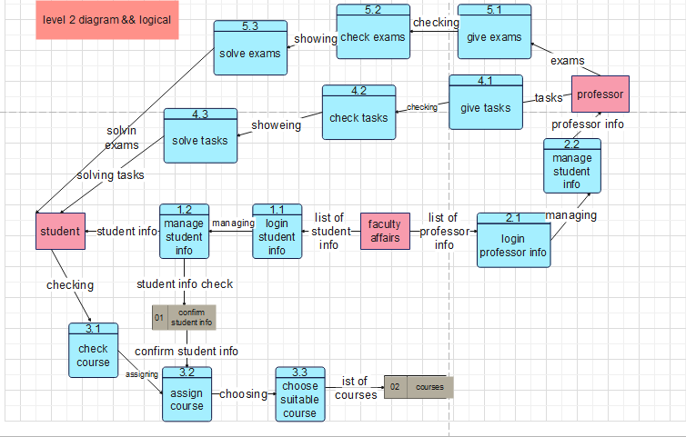

***________________________________***

***“Physical”***

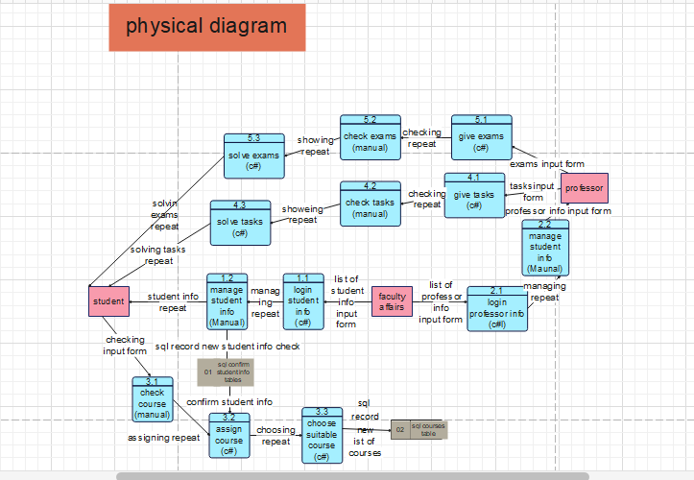

***________________________***

***“ERD”***

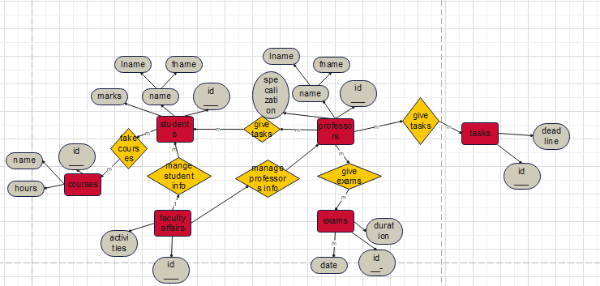

***____________________________________***

***“Data Dictionary”***

|  |  |  |  |
| --- | --- | --- | --- |
| Field name | id | deadline | name |
| Description | Id number of task | Deadline date of task | Name of task |
| Size | 2 | 8 | 30 |
| Type | Input field | Input field | Input field |
| Data type | Int | Date | Short text |
| Data format | Xx | nnnn/nn/nn | Xxxxn |
| Possible values | 40,41,42,43,44 |  | Task1 ,task2,task3,  task4,task5 |
| Validation rule | Number between 40 and 44 | Should be entered like year/month/day | task and 1number from 1 to 5 |
| Accept null | No | No | No |
| Example | 40 | 2202/2/2 | Task 1 |
| Default | 0 |  |  |

|  |  |  |
| --- | --- | --- |
| Field name | Id_professors | Id_exams |
| Description | Id number of professor | Id number of exams |
| Size | 2 | 2 |
| Type | Input field | Input field |
| Data type | Int | int |
| Data format | nn | nn |
| Possible values | 20,21,22,23,24 | 50,51,52,53,54 |
| Validation rule | Number between 20 and 24 | Number between  50 and 54 |
| Accept null | no | no |
| Example | 20 | 50 |
| default | 0 | 0 |

|  |  |  |
| --- | --- | --- |
| Field name | Id_professors | Id_students |
| Description | Id number of professor | Id number of students |
| Size | 2 | 1 |
| Type | Input field | Input field |
| Data type | Int | int |
| Data format | nn | N |
| Possible values | 20,21,22,23,24 | 1,2,3,4,5,6,7 |
| Validation rule | Number between 20 and 24 | Number between  1 and 7 |
| Accept null | no | no |
| Example | 21 | 1 |
| default | 0 | 0 |

|  |  |  |  |  |  |  |  |  |  |  |  |  |  |
| --- | --- | --- | --- | --- | --- | --- | --- | --- | --- | --- | --- | --- | --- |
| Field name | id | | Id_faculty_affairs | | | F_name | | S_name | | L_name | gpa | | |
| description | id number of student | | Id number of faculty affairs | | | Student  First  Name | | Student  Second  name | | Student  Last  name | gpa  of student | | |
| Size | 1 | | 2 | | | 10 | | 10 | | 10 | 1.1 | | |
| Type | Input field | | Input field | | | Input field | | Input field | | Input field | Input field | | |
| Data type | int | | int | | | Short text | | Short text | | Short text | float | | |
| Data format | n | | nn | | | mm… | | mm… | | mm… | n. n | | |
| Possible values | 1,2,3,  4,5,6,7 | | 70,71,72,73,74 | | | characters | | characters | | characters | 0.0 to 4.0 | | |
| Validation rule | Number  Between 1 to 7 | | Number between  70 and 74 | | | All letters should be lower case-no spaces | | All letters should be lower case-no spaces | | All letters should be lower case-no spaces |  | | |
| Accept null | no | | yes | | | Yes | | yes | | Yes | Yes | | |
| Example | 1 | | 71 | | | Ahmed | | mohamed | | Mahmoud | 3.5 | | |
| default | 0 | |  | | |  | |  | |  | 0 | | |
| Field name | | | | Id_courses | | | Id_students | | | | |
| Description | | | | Id number of courses | | | Id number of students | | | | |
| Size | | | | 2 | | | 1 | | | | |
| Type | | | | Input field | | | Input field | | | | |
| Data type | | | | Int | | | int | | | | |
| Data format | | | | Nn | | | N | | | | |
| Possible values | | | | 60,61,62,63,64 | | | 1,2,3,4,5,6,7 | | | | |
| Validation rule | | | | Number between 60 and 64 | | | Number between  1 and 7 | | | | |
| Accept null | | | | No | | | no | | | | |
| Example | | | | 60 | | | 1 | | | | |
| default | | | | 0 | | | 0 | | | | |
| Field name | | id | | | name | | | | hours | | | |
| Description | | Id number of courses | | | Name of courses | | | | Number of hours for every courses | | | |
| Size | | 2 | | | 5 | | | | 3 | | | |
| Type | | Input field | | | Input field | | | | Input field | | | |
| Data type | | int | | | Short text | | | | time | | | |
| Data format | | nn | | | Xxxxx | | | | n | | | |
| Possible values | | 60,61,62,63,64 | | | Pm,is,arc,math | | | | 1,2,3 | | | |
| Validation a rule | | Numbers of id be between 60 and 64 | | | Name should be characters from 2 to 5 and no space | | | | Then number of hours should be from 1to 3 | | | |
| Accept null | | no | | | yes | | | | yes | | | |
| Example | | 60 | | | pm | | | | 2 | | | |
| Default | | 0 | | |  | | | |  | | | |
| Field name | | id | | | datee | | | | duration | | | |
| Description | | Id number of exams | | | Date of exams | | | | Time exams have | | | |
| Size | | 2 | | | 8 | | | | 3 | | | |
| Type | | Input field | | | Input field | | | | Input field | | | |
| Data type | | int | | | date | | | | time | | | |
| Data format | | nn | | | nnnn/nn/nn | | | | n | | | |
| Possible values | | 50,51,52,53,54 | | |  | | | | 1,2,3 | | | |
| Validation a rule | | Numbers of id be between 50 and 54 | | | Date should be entered  Like year/month/day | | | | Should be from 1to 3 | | | |
| Accept null | | no | | | yes | | | | yes | | | |
| Example | | 51 | | | 2022/7/3 | | | | 2 | | | |

|  |  |  |  |  |  |  |  |  |  |  |
| --- | --- | --- | --- | --- | --- | --- | --- | --- | --- | --- |
| Field name | | | id | | | | activities | | | |
| Description | | | id number of faculty affairs | | | | Name of activity | | | |
| Size | | | 2 | | | | 10 | | | |
| Type | | | Input field | | | | Input field | | | |
| Data type | | | Int | | | | Short text | | | |
| Data format | | | nn | | | | Xxxxxxx | | | |
| Possible values | | | 70,71,72,73,74 | | | |  | | | |
| Validation a rule | | | Number between 70and 74 | | | | Maximum of characters is 10 and  all letters should be lower case letters except first letter should be upper case letter and no space | | | |
| Accept null | | | no | | | | yes | | | |
| Example | | | 72 | | | | sports | | | |
| Default | | | 0 | | | |  | | | |
| Field name | id | | | F_name | S_name | | | L_name |
| Description | Id number of professors | | | The first name | The second name | | | The last name |
| Size | 2 | | | 10 | 10 | | | 10 |
| Type | Input field | | | Input field | Input field | | | Input field |
| Data Type | int | | | Short text | Short text | | | Short text |
| Data format | nn | | | Xxxxxx | Xxxxxx | | | Xxxxxx |
| Possible values | 20,21,22,23,24,25 | | | characters | characters | | | characters |
| Validation a rule | Numbers of id be between 20 and 25 | | | All letters should be lower case letters except first letter should be upper case letter and no space | All letters should be lower case letters except first letter should be upper case letter and no space | | | All letters should be lower case letters except first letter should be upper case letter and no space |
| Accept null | no | | | no | no | | | no |
| Example | 22 | | | mohamed | foad | | | samir |
| Default | 0 | | |  |  | | |  |
| Field name | | id | | | | specialization | | | |
| Description | | Id number of professors | | | | About the specialty of professors | | | |
| Size | | 2 | | | | 2 | | | |
| Type | | Input field | | | | Input field | | | |
| Data type | | int | | | | Short text | | | |
| Data format | | nn | | | | xx | | | |
| Possible value | | 20,21,22,23,24,25 | | | | Cs,…it | | | |
| Validation a rule | | Number between 20 and 25 | | | | Name should be characters from 2 to 5 and no space | | | |
| Accept null | | no | | | | no | | | |
| Example | | 25 | | | | mm | | | |
| Default | | 0 | | | |  | | | |

|  |  |  |
| --- | --- | --- |
| Field name | Id_professors | Id_tasks |
| Description | Id number of professors | id number of tasks |
| Size | 2 | 2 |
| Type | Input field | Input field |
| Data type | int | int |
| Data format | nn | nn |
| Possible value | 20,21,22,23,24 | 40,41,42,43,44 |
| Validation a rule | Number between 20 and 24 | Number between 20 and 44 |
| Accept null | no | no |
| Example | 20 | 40 |
| Default | 0 | 0 |

_______________________________________

**“Questionnaire after implementation”**

**College management system**

**Analysist name: Manar Hessin, Norhan Nageh**

**The name of the master: …………**

**Any modification: …………………..**

**_________________________________________**

**You can share this questionnaire because it is about the system of the college:**

**1)** **Has our own satellite meets all the needs?**

**Yes No**

**2) How can we improve our system?**

**3)** **If our system doesn’t meet your goal tell us why?**

**4)** **Does the student part need additions or adjustments ? Why?**

**Yes No**

**5)** **Does the professor part need additions or adjustments? Why?**

**Yes No**

**6)** **Is the student’s part better or the professor’s part and how do we make them equal?**

**7)Does our system help everyone?**

**Yes No**

**8)** **Our system added features to the college before it existed. Explain it.**

**Yes No**

**9)** • **Which of the following words describes our system?**

**A) Full of problems. B) Good but has problem.**

**C) Excellent. D) Best system I’ve dealt with**.

**10) What features are most valuable to you in our system?**